Pawan Chandra

CSC 153

April 16, 2019

**Forensic Investigation**

**Info:** I used both OSForensics and Autopsy to do the following report however, every image shown below was from Autopsy as the user interface is a lot friendlier. It was easy to navigate and find information you need. A major drawback is that Autopsy is slow compared to OSForensics and has less features. I would say OSForensics is harder to use but more useful than Autopsy.

1: These screen shots are in order of what is required by the guidelines given in the assignment. I could not figure out how to get Slack space information.

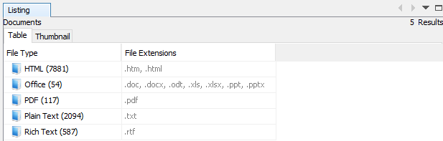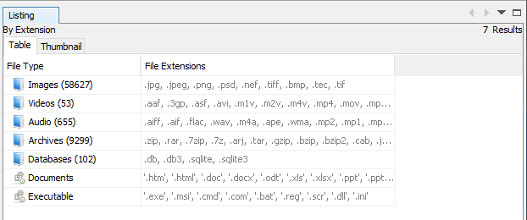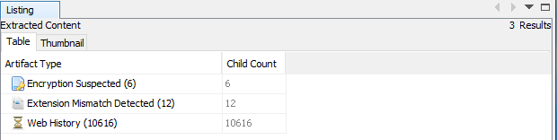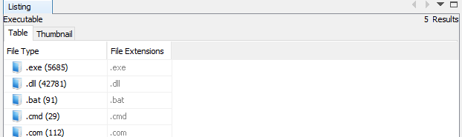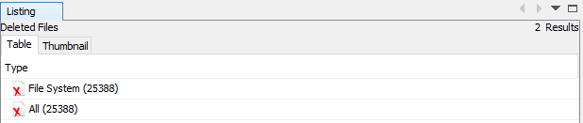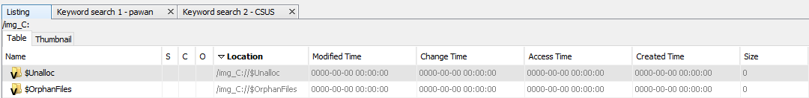

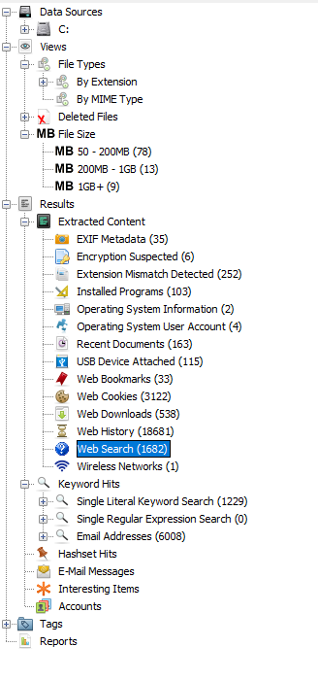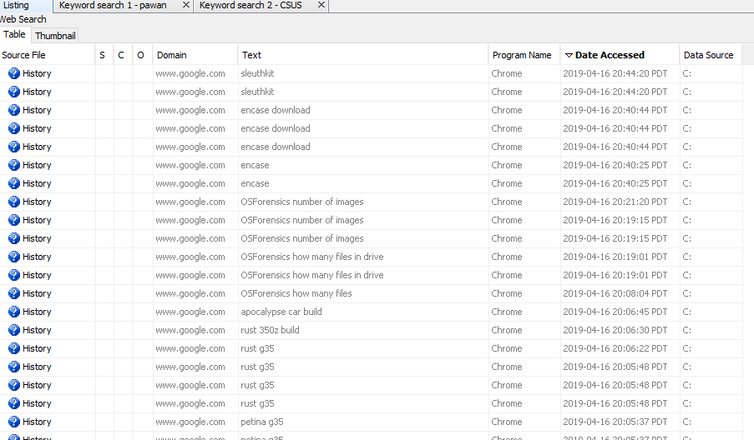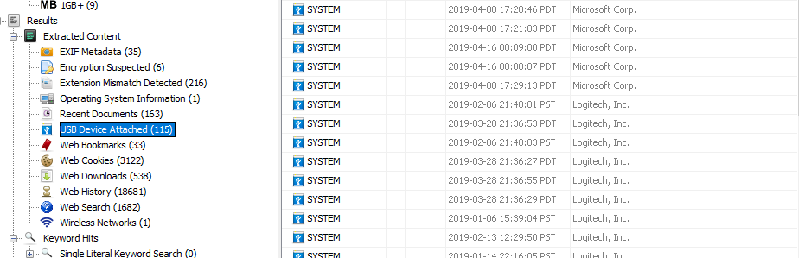

2: Screenshot of my name search with over 1000 results

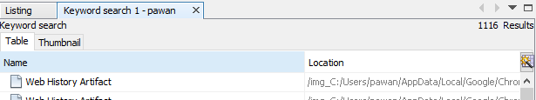

3: Upon searching, CSUS appeared 113 times in different files. Screenshot below

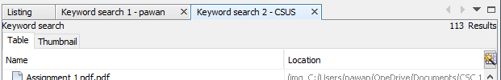

4: I am truly surprised on how many information the hard drive keeps even if you delete or uninstall the files or software. I did not expect the Autopsy to search through some of the files in my ONE Drive.